Marketing coup of industrial plots in Ähtäri
In February - March 2021, the City of Ähtäri shall carry out a marketing coup of industrial plots. The aim is to attract more companies to the area and improve the City’s prerequisites for growth and employment.
The marketing coup shall be carried out between 22/2 - 15/3/2021. All in all, seven industrial plots are available in an industrial area located in the city centre's vicinity that has excellent transport connections.
−In the same way as Ähtäri, every municipality is considering measures for strengthening growth and employment. We wanted to respond to this demand on our part with a clear and bold marketing coup suitable for Ähtäri’s image, explains Jarmo Pienimäki, Mayor of Ähtäri, as he tells about the background of the campaign he has developed.
−We also know how busy entrepreneurs are with their own work. Therefore, we are offering the most effortless turnkey solution possible. We believe that this campaign will raise interest on a wider scale too.
The plots shall be sold to companies on a turnkey basis so that the package includes water and sewage connections implemented by the City and a report on the type of foundation, which ensures the prerequisites for the construction of an industrial property. The City of Ähtäri shall also be responsible for the subdivision fees of the unseparated parcels. On the other hand, the plot owner shall be responsible for the electricity, heating and telecommunication connections.
The sales of the plots shall be implemented with a tender. The tender submission period is 22/2/ - 15/3/2021. The prerequisites for tender approval are that the tenderer agrees to build an industrial property on the plot, which has an employment-increasing effect, and that the construction work on the plot is initiated no later than during the year 2022. The plot must not be sold on as a non-constructed plot or constructed plot during the first five years without consent from the City of Ähtäri.
The local government board of Ähtäri shall approve plot transactions. The City reserves the right to accept or refuse any received tenders.

More information:
Development Engineer Tuomas Collin, tel. 040 700 8294, email: tuomas.collin@ahtari.fi

Annex: Map and surface areas of plots available for purchase

ANNEX

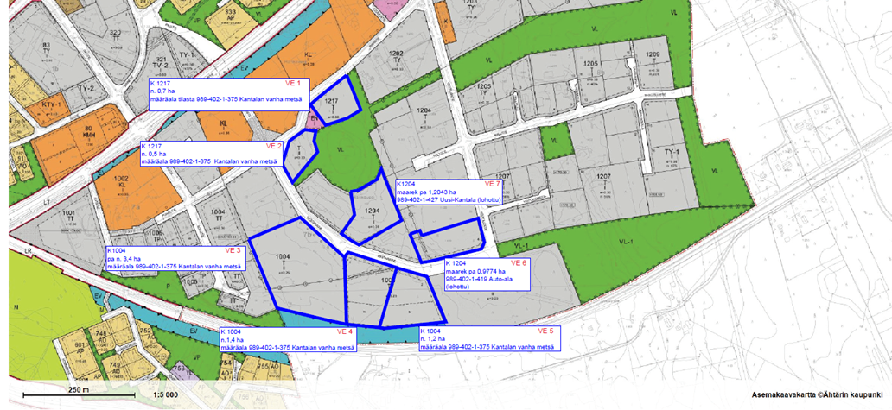

Plots available for purchase:

- unseparated parcels Kantalan Vanha Metsä real property unit 989-402-1-375:
option 1 / approx. 0.7 ha plot in block 1217
option 2 / approx. 0.5 ha plot in block 1217
option 3 / approx. 3.4 ha plot in block 1004
option 4 / approx. 1.4 ha plot in block 1004
option 5 / approx. 1.2 ha plot in block 1004
option 6 / 0.9774 ha plot in block 1204/ Parking area 989-402-1-419,
option 7 / 1.2043 ha plot in block 1204/ Uusi-Kantala 989-402-1-
427

